Exercise Javascript Functions

**Evaluated skills :**

*→ Functions*

**Question 1 :** Declare a named function, which simply displays the text Hello world! in an alert ().

**Question 2 :** Declare a function that requests a number from the user.

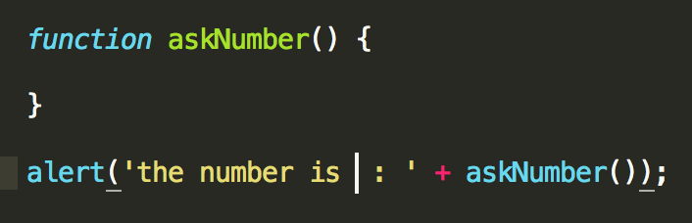

Finish writing the function askNumber () which will ask the user to enter a number with a prompt (). Once the number is entered, the function will convert the entered character string to a number, and it will check if it is a number. If it is not a number, the function asks the user to enter one again. As soon as the number is correct, the function returns the number with a return statement.

Three things must be used here:

a loop that repeats until the user enters a correct number,

parseInt ()

isNaN ().

You know the parseInt () function, but not isNaN (). Look at this code opposite to understand how it works :

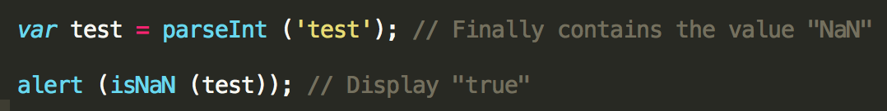

Why true? Just because isNaN () returns true when the variable is not a number, and false otherwise.

**Correction :**

**Question 1 :**

A function is declared only with the function keyword:

function myFunction () {

alert ('Hello world!');

}

It is also possible to declare a function in the same way as a variable:

var myFunction = function () {

alert ('Hello world!');

};

**Questions 2 :**

A very simple fix is ​​to create a while loop whose condition is still true, and once the user has entered a correct number, the loop is interrupted by a return

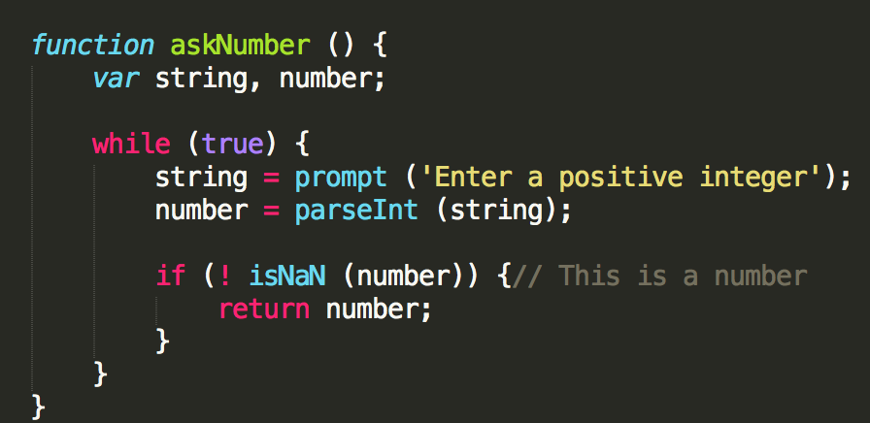

It is also possible to bend all of this, by moving the isNaN test in the while condition.

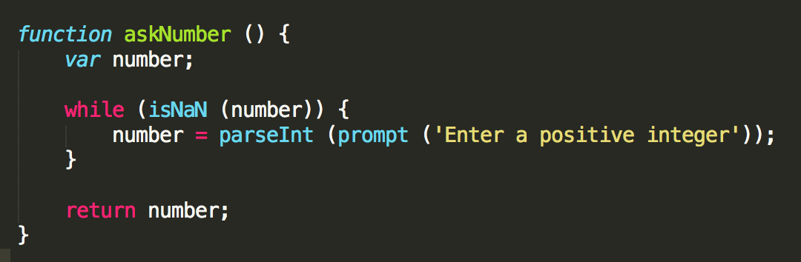

You may not have thought of the previous solution and yours certainly looked like this:

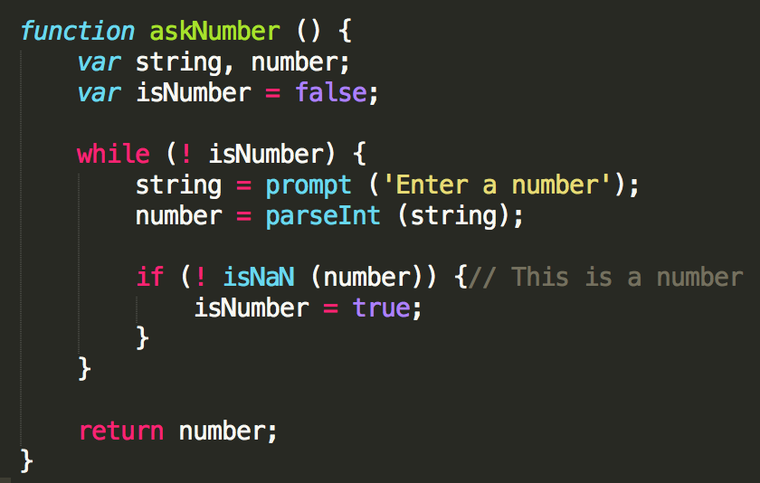

It is obviously quite correct!